UNIT 4
Syllabus: Trees – Definition, terminology, Binary trees-definition, Properties of Binary Trees, Binary Tree ADT, representation of Binary Trees - array and linked representations, Binary Tree traversals, Inorder, Postorder, Preorder, Binary Search Tree ADT – BST traversal, BFS and DFS.
========================================================================
Tree Data Structure: It is a way of storing or organizing data in the memory, in such a way that access, management and modification becomes efficient.
Linear Data Structure: Data is arranged in a sequential manner where a logical start and logical end. Every element has a next element and previous element.
Examples: Arrays, Stack, Queue and Linked Lists.
Non-Linear Data Structure: The data structure that simulates a hierarchical tree structure with a root value and sub-trees of children with parent node, represented as a set of linked nodes.
Terminology
1. Root: Root is a special node in a tree. The entire tree is referenced through it. It does not have a parent.
2. Parent node: Parent node is an immediate predecessor of a node. 3. Child node: All immediate successors of a node are its children.
4. Siblings: Nodes with the same parent are called Siblings.
5. Leaf: Last node in the tree. There is no node after this node.
6. Edge: Edge is a connection between one node after this node.
7. Path: Path is a number of successive edges from source node to destination node. 8. Degree of Node: Degree of a node is equal to number of children a node has.
Properties of a Tree
1. Tree can be termed a recursive data structure.
2. A valid tree for N Nodes has N-1 edges or links.
3. Depth of Node: Depth of a node represents the number of edges from the tree’s root node to the node.
4. Height of Node: Height of a node is the number of edges on the longest path between that node and a leaf.
5. Height of tree is the height of its root node.
Binary Tree: Every node in the tree has at most two children.

A tree is a hierarchical data structure used to organize and represent data in a parent–child relationship.
It consists of nodes, where the topmost node is called the root, and every other node can have one or more child nodes

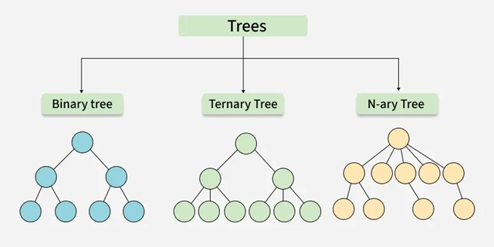

Binary Tree:
Each node can have a maximum of two children.
- Full Binary Tree – every node has either 0 or 2 children.
- Complete Binary Tree – all levels are fully filled except possibly the last, which is filled from left to right.
- Balanced Binary Tree – height difference between left and right subtrees of every node is minimal.
Ternary Tree:
Each node can have at most three children, often labeled as left, middle, and right.
N-ary Tree (or Generic Tree):
- Each node can have any number of children.
- Each node typically contains: Some data , A list of references to its children (duplicates are not allowed).
- Unlike linked lists, nodes store references to multiple child nodes.

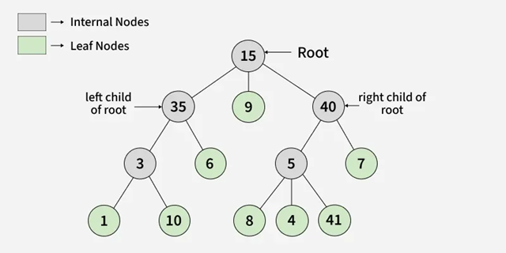

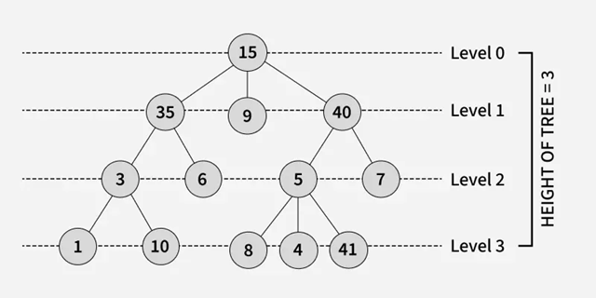

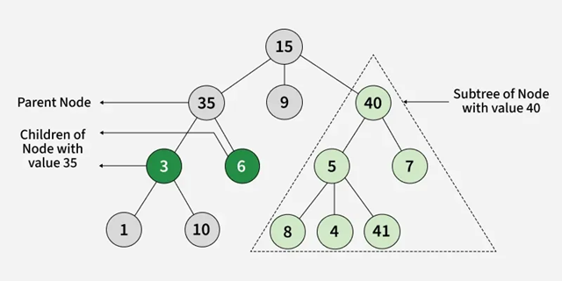
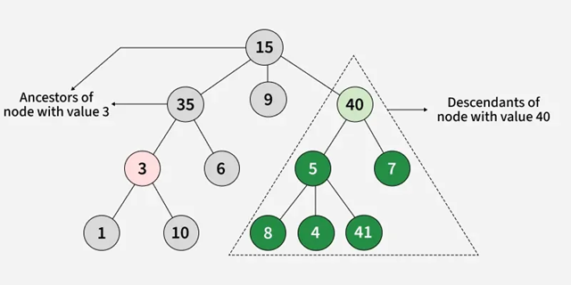
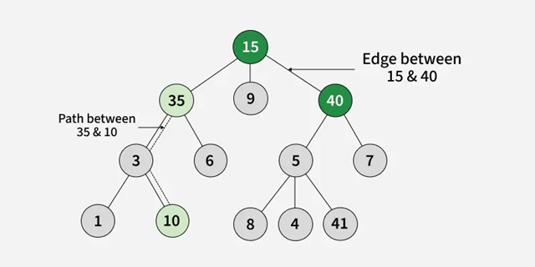

Parent Node: A node that is an immediate predecessor of another node. Example: 35 is the parent of 3 and 6.
Child Node: A node that is an immediate successor of another node. Example: 3 and 6 are children of 35.
Root Node: The topmost node in a tree, which does not have a parent. Example: 15 is the root node.
Leaf Node (External Node): Nodes that do not have any children. Example: 1, 10, 12, 5, 7, 7 are leaf nodes.
Ancestor: Any node on the path from the root to a given node (excluding the node itself). Example: 15 and 35 are ancestors of 10.
Descendant: A node x is a descendant of another node y if y is an ancestor of x. Example: 1, 10, and 6 are descendants of 35.
Sibling: Nodes that share the same parent. Example: 1 and 10 are siblings, and 5 and 7 are siblings.
Level of a Node: The number of edges in the path from the root to that node.The root node is at level 0.
Internal Node: A node with at least one child.
Neighbor of a Node: The parent or children of a node.
Subtree: A node and all its descendants form a subtree.
Degree:
The degree of a node = number of children that node has.
The degree of the tree = highest degree among all nodes in the tree.
Why Tree is considered a non-linear data structure?
Data in a tree is not stored sequentially (i.e., not in a linear order). Instead, it is organized across multiple levels, forming a hierarchical structure. Because of this arrangement, a tree is classified as a non-linear data structure.

Applications of Tree Data Structure
1. Store hierarchical data like folder structure, organization structure data. 2. Binary Search Tree is a tree that allows fast search, insert, delete on a sorted data. 3. Heap is a tree data structure that is implemented using arrays and used to implement priority queues.
4. B-Tree and B+ Trees are used to implement indexing in databases. 5. Used to store router-tables in routers.
6. Used by compiler to build syntax trees.
7. Used to complement expression parser and expression solvers.

Binary Tree: A binary tree is a tree data structure in which each node has at most two children which are referred to as the left child and the right child.

Types of Binary Tree:
- Binary Search Tree (BST) and its Variations: A BST is a binary tree where each node has at most two children, and for each node, the left child’s value is smaller than the node’s value, and the right child’s value is greater.
- Binary Indexed Tree (Fenwick Tree): A data structure that uses a binary tree to efficiently compute and update prefix sums in an array.
- Balanced Binary Tree: A binary tree where the difference in heights between the left and right subtrees of any node is minimal (often defined as at most 1). Examples of Balanced Binary Tree are AVL Tree, Red Black Tree and Splay Tree.
A Binary Tree Data Structure is a hierarchical data structure in which each node has at most two children, referred to as the left child and the right child.

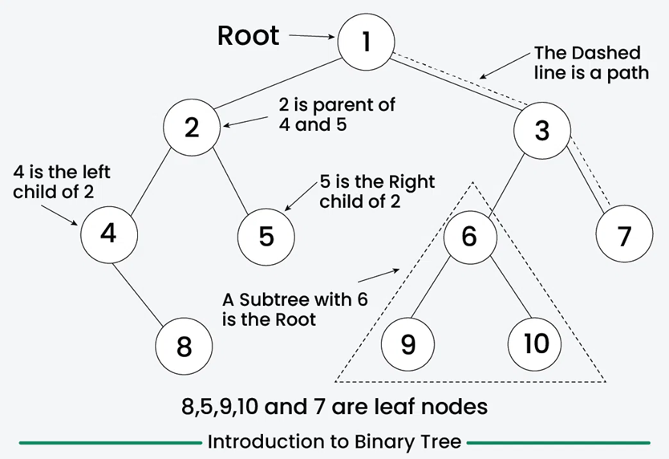

Properties of Binary Trees
1. Maximum Nodes at Level 'l'
A binary tree can have at most 2^{l} nodes at level l.
- Level Definition: The number of edges in the path from the root to a node. The root is at level 0.
- Proof by Induction:
Base case: For root (l = 0), nodes = 2⁰ = 1.
Inductive step: If level l has 2^{l} nodes, then the next level has at most twice as many:
2×2^{l} = 2^{l}+1
2. Maximum Nodes in a Binary Tree of Height 'h'
A binary tree of height h can have at most 2^{h+1} - 1 nodes.
- Height Definition: The longest path from the root to a leaf node. Please note that a tree with only one root node is considered to have height 0 and an empty tree (or root is NULL) is considered to have height "-1"
Formula Derivation: A tree has the maximum nodes when all levels are completely filled. Summing nodes at each level:
1 + 2 + 4 +...+ 2^{h} = 2^{h+1} - 1
- Alternate Height Convention: Some books consider a tree with only one root node is considered to have height 1 and an empty tree (or root is NULL) is considered to have height 0. making the formula 2^{h} - 1.

3. Minimum Height for 'N' Nodes
- The minimum possible height for N nodes is ⌊log₂N⌋.
- Explanation: A binary tree with height h can have at most 2^{h+1} - 1 nodes.
- Rearranging:
- N ≤ 2^{h+1} − 1
2^{h+1} ≥ N+1
h ≥ log₂​(N+1) - 1 (Taking log2 both sides)
h ≥ ⌊log₂​N⌋
- This means a binary tree with N nodes must have at least ⌊log₂N⌋ levels.

4. Minimum Levels for 'L' Leaves
A binary tree with L leaves must have at least ⌊log₂L⌋ levels.
Why? A tree has the maximum number of leaves when all levels are fully filled.
From Property 1:
L ≤ 2^{l} ( l is the level where leaves appear)
Solving for l:
l_{min} = ⌊log₂L⌋
This gives the minimum levels needed to accommodate L leaves.
5. Nodes with Two Children vs. Leaf Nodes
In a full binary tree (where every node has either 0 or 2 children), the number of leaf nodes (L) is always one more than the internal nodes (T) with two children:
L=T+1
Proof:
A full binary tree has a total of 2^{h+1} - 1 nodes.
Leaves are at the last level: L = 2^{h}.
Internal nodes: T =2^{h (2−1}) − 1= 2^{h} - 1.
Simplifies to L=T+1
Total Edges in a Binary Tree
In any non-empty binary tree with n nodes, the total number of edges is n - 1.
Every node (except the root) has exactly one parent, and each parent-child connection represents an edge.
Since there are n nodes, there must be n - 1 edges.

Tree Traversal Methods
Tree traversal is categorized into Depth-First Search (DFS) and Breadth-First Search (BFS):
- DFS Traversals: Explore one branch fully before backtracking.
  - In-Order (LNR): Left → Node → Right (retrieves BST elements in sorted order).
  - Pre-Order (NLR): Node → Left → Right (used for tree reconstruction).
  - Post-Order (LRN): Left → Right → Node (helps in deleting or evaluating expressions).
- BFS Traversals: Visit nodes level by level.
  - Level-Order: Processes nodes from top to bottom (used in shortest path algorithms).
Zig-Zag Traversal: Alternates left-to-right and right-to-left at each level (used in hierarchical structure

Example :
1
/ \
2 3
/ \
4 5

Preorder: 1 2 4 5 3
Inorder: 4 2 5 1 3
Postorder: 4 5 2 3 1
By contrast, BFS (Breadth-First Search) for trees is level order traversal:
- Level order: 1 2 3 4 5

Binary Tree – Implementation View
Node (*left, data, *right)
Node class
Node
{
Node *left;
Int data;
Node *right;
}

Representation of Binary Tree Using Arrays
A binary tree is a hierarchical data structure composed of nodes, where each node has at most two children, referred to as the left child and the right child. One way to represent a binary tree in a computer's memory is by using an array. This representation is known as an array representation of a binary tree.
Terminology and Properties.
Node Structure
Each node in a binary tree contains data, a reference (link) to the left child, and a reference to the right child.
In the array representation, the index of an element corresponds to its position in the tree.
Array Representation - Level Order Traversal:
∙ In a binary tree represented by an array, nodes are filled level by level, starting from the root.
∙ The root is at index 0, and for any node at index i:
∙ Its left child is at index 2*i + 1.
∙ Its right child is at index 2*i + 2.
∙ A binary tree is called strict binary tree when each node has 2 or 0 children. ∙ A binary tree is called complete binary tree if all levels except the last are completely filled and all nodes are as left as possible.
∙ A binary tree is called perfect binary tree of all levels are completely filled with 2 children each.
∙ Maximum number of nodes at level ‘x’ = 2^{x}
∙ For a binary tree, maximum number of nodes with height ‘h’ = 2⁰ + 2¹ +……. +2^{h} = 2^{(h+1)}-1
Binary Tree implementation using Arrays
#include <iostream>
#include <vector>
using namespace std;
class BinaryTree
{
private:
int* tree;
int size;
public:
BinaryTree(int maxSize)
{
size = maxSize;
tree = new int[size];
for(int i=0;i<size;i++)
tree[i] = -1;
}
~BinaryTree()
{
delete[] tree;
}
void insert(int value)
{
insertRecursive(value,0);
}
void display()
{
for(int i=0;i<size;i++)
{
if(tree[i] != -1)
cout << tree[i] << " ";
else
cout << "- ";
}
}
private:
void insertRecursive(int value,int index)
{
if(index >= size)
return;
if(tree[index] == -1)
tree[index] = value;
else if(value <= tree[index])
insertRecursive(value,2*index+1);
else
insertRecursive(value,2*index+2);
}
};
int main()
{
int n;
cin >> n;
BinaryTree binaryTree(20);
vector<int> elements(n);
for(int i=0;i<n;i++)
cin >> elements[i];
for(int i=0;i<n;i++)
binaryTree.insert(elements[i]);
binaryTree.display();
}
Representation of Binary Tree Using Linked Lists
A binary tree is a hierarchical data structure where each node has at most two children, referred to as the left child and the right child. One common way to represent a binary tree is through linked lists. In this representation, each node in the binary tree is represented by a linked list node, and pointers are used to connect nodes to represent the left and right children.
Basics of Binary Trees
Node Structure:
Each node in a binary tree contains data, a reference (link) to the left child, and a reference to the right child.
Linked List Representation:
Node Definition
A binary tree node is represented as a struct or class with data and two pointers (left and right) pointing to the left and right children.
Binary tree representation using linked lists
#include <iostream>
#include <queue>
using namespace std;
struct TreeNode
{
int data;
TreeNode* left;
TreeNode* right;
TreeNode(int value)
{
data = value;
left = NULL;
right = NULL;
}
};
TreeNode* createBinaryTreeLevelOrder()
{
int value;
cout << "Enter root value (-1 for no node): ";
cin >> value;
if (value == -1)
return NULL;
TreeNode* root = new TreeNode(value);
queue<TreeNode*> q;
q.push(root);
while (!q.empty())
{
TreeNode* current = q.front();
q.pop();
cout << "Enter left child of " << current->data << " (-1 for no node): ";
cin >> value;
if (value != -1)
{
current->left = new TreeNode(value);
q.push(current->left);
}
cout << "Enter right child of " << current->data << " (-1 for no node): ";
cin >> value;
if (value != -1)
{
current->right = new TreeNode(value);
q.push(current->right);
}
}
return root;
}
void inorder(TreeNode* root)
{
if (root != NULL)
{
inorder(root->left);
cout << root->data << " ";
inorder(root->right);
}
}
int main()
{
TreeNode* root = createBinaryTreeLevelOrder();
cout << "\nInorder Traversal: ";
inorder(root);
return 0;
}
Binary Tree -Traversal Techniques
Tree traversal also known as tree search and walking the tree refers to the process of visiting (checking or updating) each node in a tree data structure, exactly once. The traversals are classified by the order in which the nodes are visited.
Tree Traversal
Depth-first-Search / traversal (DFS) Breadth first search / traversal (BFS)
1. Pre-order (NLR) Trees can also be traversed in level 2. In-order (LNR) order, where visiting every node on a 3. Post-order (LRN) level before going to a lower level. This Search is referred to as breadth-first
search as the search tree is broadened
as much possible on each depth before
going to the next level.
Pre-order (NLR) | In-order (LNR) | Post-order (LRN)
Access the data part of the current node  Traverse the left subtree by recursively calling the pre order function.  Traverse the right subtree by recursively calling the pre-order function.  Pseudocode  void printPreorder (TreeNode* r) {  1. if (r==NULL) return;  2. print (r-> value);  3. printPreorder (r -> left)  4. printPreorder (r -> right)  } | Traverse the left subtree by recursively calling the in order function.  Access the data part of the current node.  Traverse the right subtree by recursively calling the in order function.  In BST in-order traversal retrieves the keys in ascending sorted order.  Pseudocode  void printInorder (TreeNode* r) {  1. if (r==NULL) return;  2. printInorder (r -> left)  3. print (r-> value);  4. printInorder (r -> right)  } | Traverse the left subtree by recursively calling the post order function.  Traverse the right subtree by recursively calling the post-order function.  Access the data part of the current node.  Pseudocode  void printPostorder (TreeNode* r) {  1. if (r==NULL) return;  2. printPostorder (r -> left)  3. printPostorder (r -> right)  4. print (r-> value);  }

Example
30
/ \
18 43
/ \ / \
10 25 32 48

DFS Travarsal:
Inorder Traversal (Left → Root → Right)
This gives sorted order for BST:
Result:
10 18 25 30 32 43 48
Preorder Traversal (Root → Left → Right)
Result:
30 18 10 25 43 32 48

Postorder Traversal (Left → Right → Root)
Result:
10 25 18 32 48 43 30

Level – order (BFS): Tree can be traversed level-order where visiting every node in the same level before going to lower level.
Result 30, 18, 43, 10, 25, 32, 48
Program for DFS
#include <iostream>
using namespace std;
// Node structure (Linked representation of Binary Tree)
struct Node
{
int data;
Node* left;
Node* right;
};
// Function to create a new node
Node* createNode(int value)
{
Node* temp = new Node;
temp->data = value;
temp->left = NULL;
temp->right = NULL;
return temp;
}
// Function to build Binary Tree from input values
Node* buildTree(int arr[], int index, int n)
{
if (index >= n)
return NULL;
Node* root = createNode(arr[index]);
root->left = buildTree(arr, 2 * index + 1, n);
root->right = buildTree(arr, 2 * index + 2, n);
return root;
}
// Inorder Traversal
void inorder(Node* root)
{
if (root != NULL)
{
inorder(root->left);
cout << root->data << " ";
inorder(root->right);
}
}
// Preorder Traversal
void preorder(Node* root)
{
if (root != NULL)
{
cout << root->data << " ";
preorder(root->left);
preorder(root->right);
}
}
// Postorder Traversal
void postorder(Node* root)
{
if (root != NULL)
{
postorder(root->left);
postorder(root->right);
cout << root->data << " ";
}
}
int main()
{
int n;
cout << "Enter number of nodes: ";
cin >> n;
int arr[n];
cout << "Enter " << n << " node values:\n";
for (int i = 0; i < n; i++)
cin >> arr[i];
// Create Binary Tree
Node* root = buildTree(arr, 0, n);
cout << "\nInorder Traversal: ";
inorder(root);
cout << "\nPreorder Traversal: ";
preorder(root);
cout << "\nPostorder Traversal: ";
postorder(root);
return 0;
}

Program for BFS Traversal (level order):
#include <iostream>
#include <queue>
#include <vector>
using namespace std;

// Node structure
struct Node
{
int data;
Node* left;
Node* right;
};

// Create new node
Node* createNode(int value)
{
Node* temp = new Node;
temp->data = value;
temp->left = NULL;
temp->right = NULL;
return temp;
}

// Build tree from array input
Node* buildTree(vector<int>& arr, int index, int n)
{
if (index >= n)
return NULL;

Node* root = createNode(arr[index]);
root->left = buildTree(arr, 2 * index + 1, n);
root->right = buildTree(arr, 2 * index + 2, n);

return root;
}

// Level Order Traversal
void levelOrder(Node* root)
{
if (root == NULL)
return;

queue<Node*> q;
q.push(root);

while (!q.empty())
{
Node* temp = q.front(); // fixed line
q.pop();

cout << temp->data << " ";

if (temp->left != NULL)
q.push(temp->left);

if (temp->right != NULL)
q.push(temp->right);
}
}

int main()
{
int n;
cout << "Enter number of nodes: ";
cin >> n;

vector<int> arr(n); // safer than int arr[n]

cout << "Enter " << n << " node values:\n";
for (int i = 0; i < n; i++)
cin >> arr[i];

Node* root = buildTree(arr, 0, n);

cout << "\nLevel Order Traversal: ";
levelOrder(root);

return 0;
}

Binary Search Tree (BST)
BST is also a binary tree data structure in which the values in the left subtrees of every node are smaller and the values in the right subtree of every node are larger.
Values | Keys = {25, 23, 14, 36, 29, 19, 52}
25
/ \
23 36
/ / \
14 29 52
\
19
How it was constructed (brief)
- 25 → root
- 23 < 25 → left of 25
- 14 < 23 → left of 23
- 36 > 25 → right of 25
- 29 < 36 → left of 36
- 19 > 14 → right of 14
- 52 > 36 → right of 36

Program for BST
#include <iostream>
#include <cmath>
using namespace std;
class BinaryTree
{
private:
int *tree;
int size;
public:
BinaryTree(int maxSize)
{
size = maxSize;
tree = new int[size];
for (int i = 0; i < size; ++i)
{
tree[i] = -1;
}
}
void insert(int value)
{
insertRecursive(value, 0);
}
void display()
{
cout << "Binary Tree - Array Representation ";
for (int i = 0; i < size; ++i)
{
if (tree[i] != -1)
{
cout << tree[i] << " ";
}
else
{
cout << "- ";
}
}
cout << endl;
}
private:
void insertRecursive(int value, int index)
{
if (index < size)
{ if (tree[index] == -1)
{ tree[index] = value; }
else
{ if (value <= tree[index])
{ insertRecursive(value, 2 * index + 1);
}
else
{ insertRecursive(value, 2 * index + 2);
}
}
}
}
};
int main()
{
BinaryTree binaryTree(25);
int elements[] = {8, 4, 12, 2, 6, 10, 14, 1, 3, 5, 7, 9, 11, 13, 15};
int numElements = sizeof(elements) / sizeof(elements[0]);
for (int i = 0; i < numElements; ++i)
{
binaryTree.insert(elements[i]);
}
binaryTree.display();
return 0;
}
Time Coplexities
Feature | Binary Tree | BST (Best) | BST (Worst)
Structure Rule | None | Ordered | Ordered
Search | O(n) | O(log n) | O(n)
Insertion | O(n) | O(log n) | O(n)
Deletion | O(n) | O(log n) | O(n)

To avoid worst case in BST, we use:
- AVL Tree
- Red-Black Tree
These keep height ≈ log n

Binary Search Tree as dynamic nodes in memory
Node (*left, data, *right);
Node Class
class TreeNode
{
Data Members:
1. int value;
2. TreeNode * left;
3. TreeNode *right;
Member Functions:
TreeNode (); //default constructor
TreeNode (int v) //parameterized constructor
}
BST Class
Class BST
{
Data Members:
1. TreeNode * root
Member Functions:
1. bool isTreeEmpty ()
2. void insertNode
(TreeNode *new_node) // insertion
//Depth First Traversal approach
3a. void printPreorder (TreeNode * r) print and traverser
3b. void printInorder (TreeNode* r) //print and traverse
3c. void printPostorder (TreeNode* r) //print and traverse
3d. void print2D (TreeNode* r, int space) //print and traverse
3e. void printLeverOrder (TreeNode* r) // print and traverse
//breadth first traversal approach
4. TreeNode* search (TreeNode* r, int v) //search
5a. TreeNode* minValueNode (TreeNode* node) // delete
5b. TreeNode* deleteNode (TreeNode* r, int v) // delete
}
Pseudocode for Inserting a node into BST
void insertNode(new_node)
{
1. If root == NULL then root = new_node
2. else
2.1 set temp = root
2.2 while temp! = NULL
2.2.1 if new_node. value == temp.value
2.2.1.1 then return //duplicate values are allowed
2.2.2 else if (new_node. value <temp.value) && (temp. left == NULL) 2.2.2.1 then temp. left = new_node // value inserted on left 2.2.2.2 break // get out of the function
2.2.3 else if (new_node.value < temp.value)
2.2.3.1 then temp = temp. left
2.2.4 else if (new_node.value > temp. value) && (temp. right == NULL) 2.2.4.1 temp. right - new_node // value inserted on right
2.2.4.2 break // get out of the function
2.2.5 else
2.2.5.1 temp = temp. right
End while
End if
} End function
}
Height of a Tree
The height of a binary tree is a number of edges between the tree’s root node and farthest leaf node.
Pseudocode for Finding height of Binary Tree | BST
int height (TreeNode* t)
{
1. if (r == NULL)
1.1 return -1
2. else
2.1 lheifht = height (r -> left)
2.2 rheight = height (r -> right)
2.3 if lheight > rheight
2.3.1 return (lheight + 1)
2.4 else
2.4.1 return (rheight + 1)
}
Algorithm for Deletion operation on Binary Tree
1. Deletion of a leaf node or node with only 1 child
1. Traverse to the leaf node or node with single child n.
2. Check if n has left child (n -> left).
If it does not link the right child (n->right) with parent node of n.
3. If n has left child, then check if n has right child.
If it does not, link the left child (n->left) with parent node of n.
Algorithm for Deletion on Binary Search Tree

2. Deletion of a leaf node or node with only 1 child
1. Traverse to the node with 2 children to be deleted (n).
2a. Find the smallest node (nMin) in the right sub tree of n.
OR
2b. Find the largest node (nMax) in the left subtree of n.
3. Replace this node (nMin) or nMax) with the node to be deleted
(Replace n with nMin).
4. Now delete nMin or nMax using the delete process again.

Pseudocode for Minimum Value Node
TreeNode* minValNode (TreeNode* node)
{
SET current = node
while (current -> left != NULL)
current = current -> left
return current
}

==00oo00==

